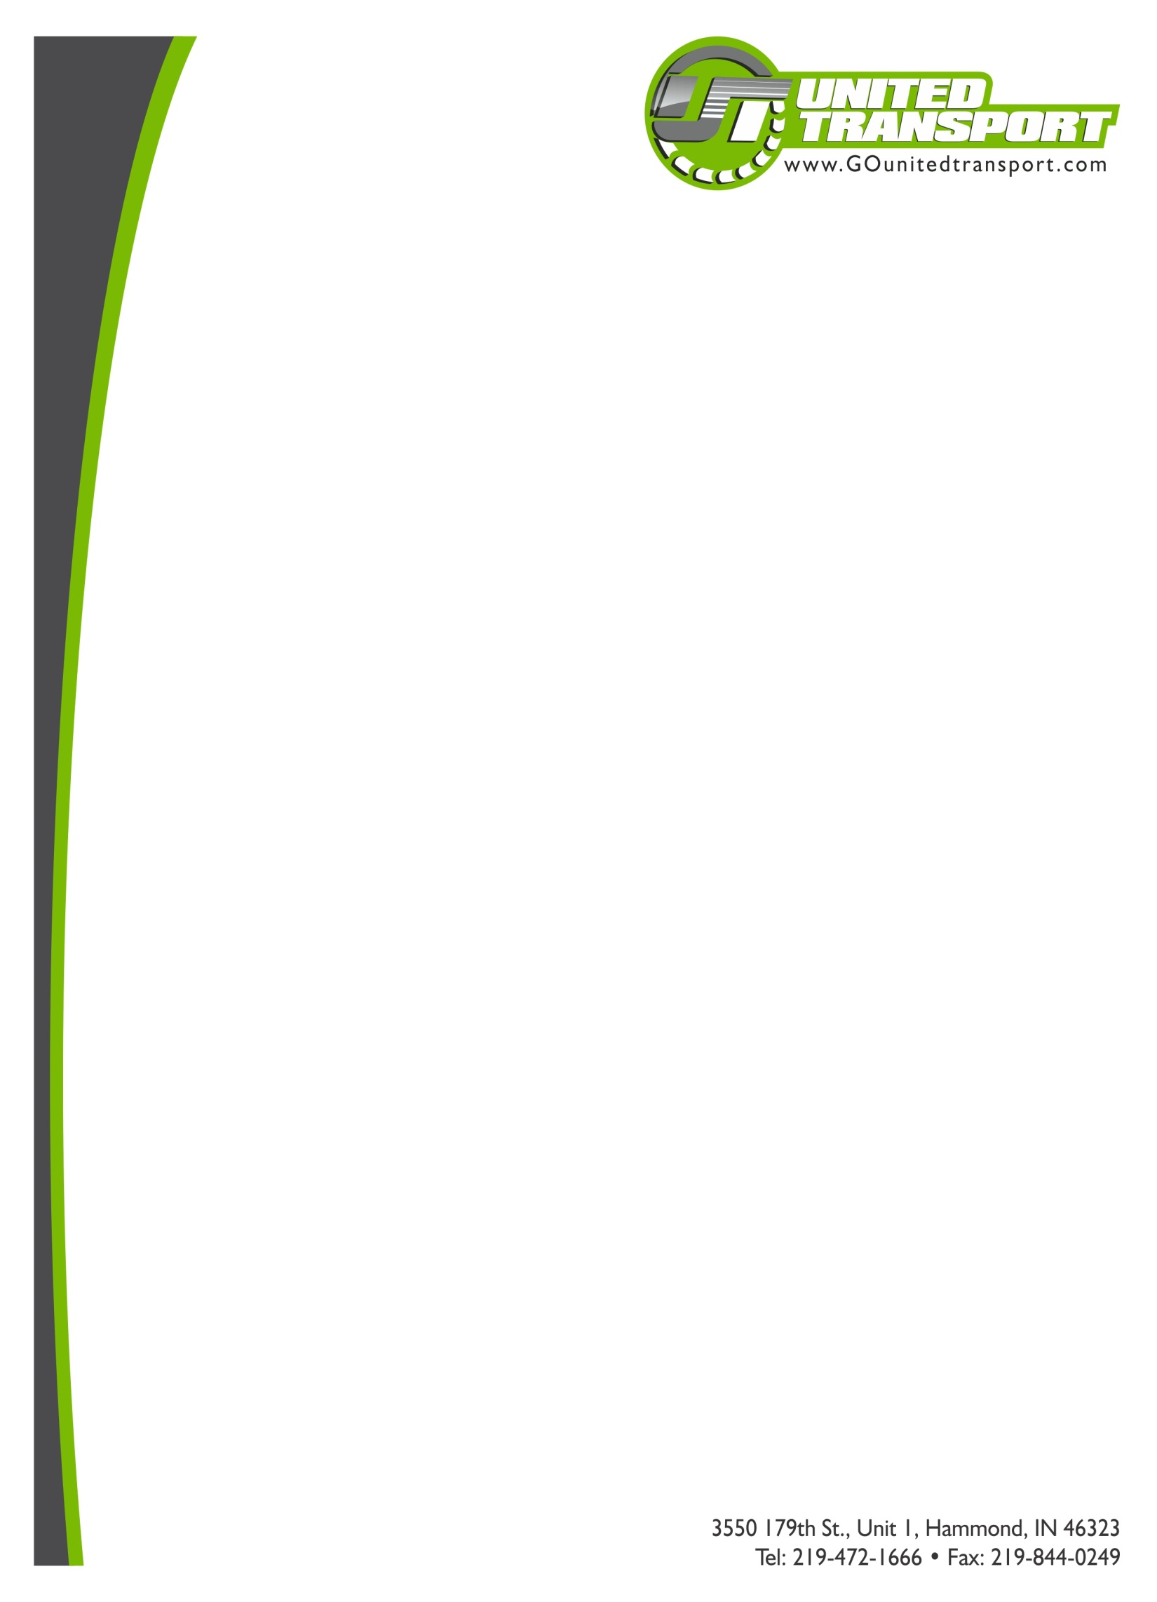

***ATTENTION DRIVERS!!!***

***ANNUAL 3-DAY DOT INSPECTION***

***June 4-6, 2014***

The annual three-day roadside commercial vehicle safety crackdown known as Roadcheck will focus this year on cargo securement and educating drivers about the upcoming changes in hours of service regulations.

***SAFETY TIPS***

*Buckle up!*

***Make sure your cargo is properly secured!***

*Pre-inspect the condition of your vehicle*

*Obey speed limits & traffic signs*

*Make only safe & necessary lane changes*

*Never drive under influence*

*Maintain in safe following distance*

*Ph: 219-472-1503 (ext.305)*

*Safety Department*