First Baptist Church Higgins

November 1912 – November 2012

100 Years of Service – Chronology

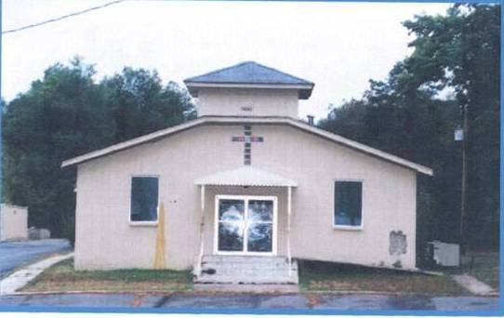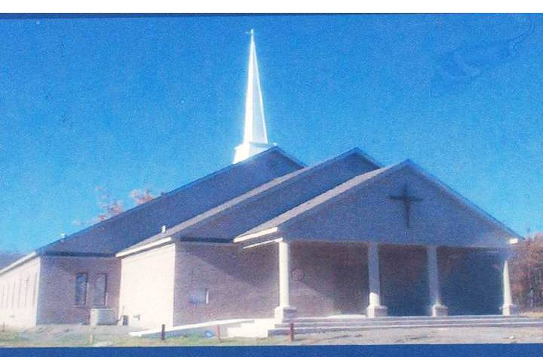

Date | Description of Accomplishments
1912 | The First Baptist Church of Higgins started with a Sunday School in the home of Brother Robert Banner. From the Sunday School grew the church with only seven members: Brother Robert Banner, his wife, their two children, Sister Mattie Oliver, Sister Amanda Oliver and Mother Rosie Sueberry.  They organized the church in November and elected Rev. Davis McFarland as pastor. The church moved its location at that time across the highway into the school. Rev. Davis McFarland made choice of the second and fourth Sunday in each month for worship. They worshipped here for five years.
1917 | Brother Charley Banner gave the church ½ acre of ground.
1921 | Rev. S. M. Gates was elected as pastor and served 10 years.
1932 | Rev. E. D. Moore was elected as pastor
1940 | The church was destroyed by fire. The members then worshipped two years in a brush harbor (temporary structure literally made of brush, chicken wire, sheets & tarp, i.e. a tent) until the temple was rebuilt. Rev. Moore served 15 years.
1946 | Rev. Alf Bosley was elected pastor and served three years.
1949 | Rev. C. R. Ramsey was elected as pastor. Under his administration bought ½ acre of land from Brother Will Standford, and moved into the church located at 9700 Highway 365 South. Rev. Ramsey served for five years.
1954 | Rev. George Wright was elected pastor. He served one year and was called to another church.
1955 | Rev. C. H. Hill was elected pastor and served three years.
1958 | Rev. V. W. Nelson was elected as pastor, and under his leadership seventy-five feet of land was purchased. Rev. Nelson served three years and was called to another church.
1961 | Rev. Duggar Johnson was elected as pastor. He served two years and then resigned. The church was destroyed by fire. Deacon Jabbo Brown went into the church and saved the Bible and ½ bench.
1964 | Rev. L. B. Kelly was elected Pastor, and under his administration a new building was completed and services were conducted.
1965 | Rev. Ulysses Robinson was elected as pastor. Under his leadership, the membership continued toward the finishing of the structure. Rev. Robinson served four years and was called to another church.
1970 | On March 15, 1970, Rev. Limmie Downs was elected as pastor. Under his administration, the building was finished. New furniture was purchased and a public address system installed. Many new members joined the church under Pastor Downs’ leadership. In 1977, Rev. Downs was called to another church.
1978 | In March 1978, Rev. James Clanton was elected as pastor. He served six and a half years. Under his administration, new additions were added to the church.
1985  to  2013  (Present) | God Promised not to leave his children alone and He did not. In March 1985, God sent to us Rev. Michael D. Payne. Under his leadership, many Associate Ministers, and new members have been added to the church. Many baptisms, weddings & baby christenings have been held. Likewise, many members, loved one & friends have gone on to be with the Lord. The names of these individuals are listed later in this publication.  Under Pastor Payne’s leadership, during the past 28 years the church has: purchased additional land & house used as rental property, built a new modern-constructed church with 350-400 person capacity; a two-story educational building housing 19 classrooms, three offices, fully industrial-equipped kitchen & pantry, handicapped facilities, youth sanctuary, and a large meeting room; installed state-of-the-art audio-visual sound & recording system; updated telephone equipment, intercom system, computers, security systems, and other technological updates; expanded & paved the lighted parking lot; purchased & installed lighted sign that also posts church events; and purchased additional vans. One major project completed in October 2012, was the construction of the Illuminated Cross. These set of three crosses are 33 feet in diameter, which reflects the 33 year ministry of Jesus Christ. Several other major projects are slated for completion in the near future.  We are proud of the accomplishments that we as a church have made, and constantly pray that God keeps us humble enough to be of service to Him. We pray that the Lord keeps us “rooted & grounded in the Faith” that we may be counted as obedient servants to Him. We thank our Heavenly Father for those who have kept the faith, stayed in the fight for right and righteousness, and who one–by-one will answer to the highest call from a righteous Father.

