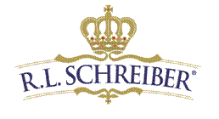

Blend Technician

R.L. Schreiber, a family owned company celebrating over 40 years in business, is Blend Technician at our facility in Lebanon, Kentucky.

Requirements:

We are currently seeking an individual with a High School Diploma or equivalent. One year as a blend technician in food or other manufacturing environment. In this role, you will perform a number of duties/roles, including:

- Assist in ingredient preparation and blending of products with standardized recipes
under strict quality controls
- Insure products are prepared to recipe and blend instructions in a clean, neat &
organized manner
- Coordinate supply of raw materials and packaging supplies to blending room
- Use RF Scanners to move needed raw and packaging materials to blending and
- packaging work centers
- Insures “First Expired, First Out” raw material rotation using barcodes and lots
- Observes “Good Manufacturing Practices”
- Operate power equipment to move materials as needed

The ideal qualified candidates will have experience in a manufacturing environment. Able to work in dusty or wet conditions, work independently to meet production requirements, and keep daily sanitation and maintenance of both quality and production logs. Please submit your resume to tleon@rlsinc.com.

